BK restaurant Management System
Software Requirements Specification
Version 1.0

SENG 31242 – System Design Project

Group: 01

Team Members:-
SE/2022/020 Sachin Lakshitha
SE/2022/023 – Duvini Nimethra
SE/2022/026- Dinuja Ranaweera
SE/2022/030- Nethmi Navodya

Table of Contents

- Introduction
  - Purpose and Scope
  - Definitions, Acronyms, Abbreviations
  - References
  - Overview of Document

- Overall Description
  - Product Perspective (context diagram)
  - User Classes and Characteristics (personas)
  - Operating Environment
  - Design and Implementation Constraints
  - Assumptions and Dependencies

- System Analysis
  - Fact-gathering techniques used
  - Existing system analysis (with pain points)
  - Use Case Diagram (system boundary)
  - Use Case Descriptions (one per use case)
  - Activity Diagrams (one per major use case)
  - System Sequence Diagrams (high-level)

- Functional Requirements

- Non-Functional Requirements
  - Performance, Security, Usability, Reliability, Scalability, Maintainability

- Alternative Solutions & Feasibility Study

Software Requirements Specification

- Introduction

  - Purpose and Scope
The purpose of this document is to specify the software requirements for the BK Restaurant Management System. This system aims to digitize and centralize operations for BK Restaurant and BK Bar across its three branches (Ambalangoda and Kahawa). The scope includes a custom Point of Sale (POS) system, a proprietary mobile application for delivery riders with live GPS tracking, automated inventory management, and a centralized web dashboard for multi-branch monitoring. It directly replaces the current manual operations dependent on WhatsApp, physical books, and unmonitored delivery assignments

  - Definitions, Acronyms, Abbreviations
Definitions
Restaurant Owner — The primary user who manages all three branches’
Employee (Reception / Kitchen) — A supporting user who handles walk-in orders at the POS counter, prepares food based on real-time kitchen displays, and manages their attendance.
Delivery Rider — An operational user who receives delivery assignments, navigates to customer locations.
Supplier — A supporting external user who receives digital inventory requests and confirms stock availability
Acronyms
- POS: Point of Sale
- GPS: Global Positioning System
- SRS: Software Requirements Specification
- UC: Use Case
- FR: Functional Requirement
- NFR: Non-Functional Requirement
- SME: Small and Medium Enterprise
  - References
- Aggarwal, S. (2018). Modern Web Development with React. Packt Publishing.
- Boysen, N., Fedtke, S., & Schwerdfeger, S. (2021). Last-mile delivery concepts: a survey from
- an operational research perspective. OR Spectrum, 43, 1–58.
- Dixon, M., Freeman, K., & Toman, N. (2020). Digital POS systems and their impact on
- restaurant operations. Cornell Hospitality Quarterly, 61(2), 45–60.
- Google Developers. (2023). Flutter: Build apps for any screen. https://flutter.dev
- Gupta, S. (2016). The impact of technology on restaurant operations. International Journal of
- Hospitality Management, 55, 91–102.
- Heizer, J., Render, B., & Munson, C. (2019). Operations Management: Sustainability and Supply
- Chain Management (13th ed.). Pearson.
- Kasavana, M. L., & Cahill, J. J. (2007). Managing Computers in the Hospitality Industry (5th
- ed.). American Hotel & Lodging Educational Institute.
- Law, R., Buhalis, D., & Cobanoglu, C. (2013). Progress on information and communication
- technologies in hospitality and tourism. International Journal of Contemporary Hospitality
- Management, 26(5), 727–750.
- National Restaurant Association. (2023). Restaurant Technology Landscape Report 2023.
- https://restaurant.org
- Pigatto, G., Machado, J. G. C. F., Negreti, A. S., & Machado, L. M. (2017). Have you chosen your
- request? Analysis of online food delivery companies in Brazil. British Food Journal, 119(3),
- 639–657.
- Statista. (2024). Online food delivery market worldwide. https://www.statista.com

  - Overview of Document
This document follows the standard SRS structure for SENG 31242. Section 2 provides a high-level product description. Section 3 covers the system analysis including existing pain points and use cases. Sections 4 and 5 detail the functional and non-functional requirements. Section 6 provides an alternative solutions analysis and feasibility study

- Overall Description

  - Product Perspective (context diagram)
  - User Classes and Characteristics (personas)
  - Operating Environment

  - Design and Implementation Constraints
- System must function effectively in areas with poor internet connectivity (Kahawa/Ambalangoda), requiring local caching/sync mechanisms.
- Must remain cost-effective to avoid the high overhead of global SaaS competitors.
- UI must be extremely intuitive for non-technical staff.

  - Assumptions and Dependencies

- Delivery riders possess personal smartphones with functioning GPS.
- Branches have necessary hardware (PCs/Tablets, receipt printers) for POS installation.

- System Analysis

  - Fact-gathering techniques used
- Structured Client Interviews (Mr. N. C. Sanjeewa De Silva)
- Literature Review of Restaurant Management Systems
  - Existing system analysis (with pain points)
The current system relies heavily on manual labor, WhatsApp, and physical ledgers. Key pain points include:
- Missed or duplicated orders due to WhatsApp traffic.
- Complete lack of delivery rider visibility (blind dispatch).
- Unnoticed low inventory resulting in frequent stockouts and manual supplier calls.
- Inability to perform cross-branch financial comparison without manual calculations.
- Paper-based employee management leading to scheduling conflicts.

  - Use Case Diagram
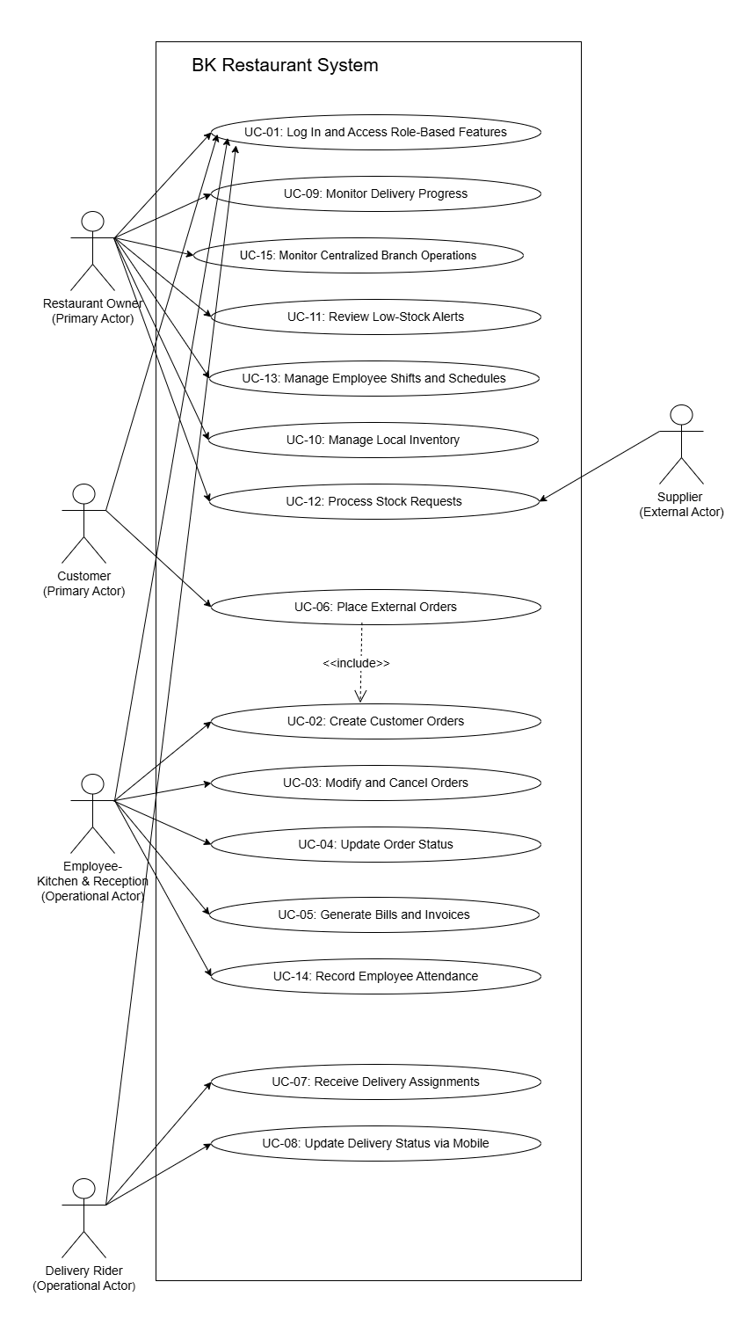
  - Use Case Descriptions (one per use case)
Below is a summarized list of core system use cases
- UC-01: Log In and Access Role-Based Features
- UC-02: Create Customer Orders
- UC-03: Modify and Cancel Orders
- UC-04: Update Order Status
- UC-05: Generate Bills and Invoices
- UC-06: Place External Orders
- UC-07: Receive Delivery Assignments
- UC-08: Update Delivery Status via Mobile
- UC-09: Monitor Delivery Progress
- UC-10: Manage Local Inventory
- UC-11: Review Low-Stock Alerts
- UC-12: Process Stock Requests
- UC-13: Manage Employee Shifts and Schedules
- UC-14: Record Employee Attendance
- UC-15: Monitor Centralized Branch Operations & Analytics

  - Activity Diagrams (one per major use case)
01.
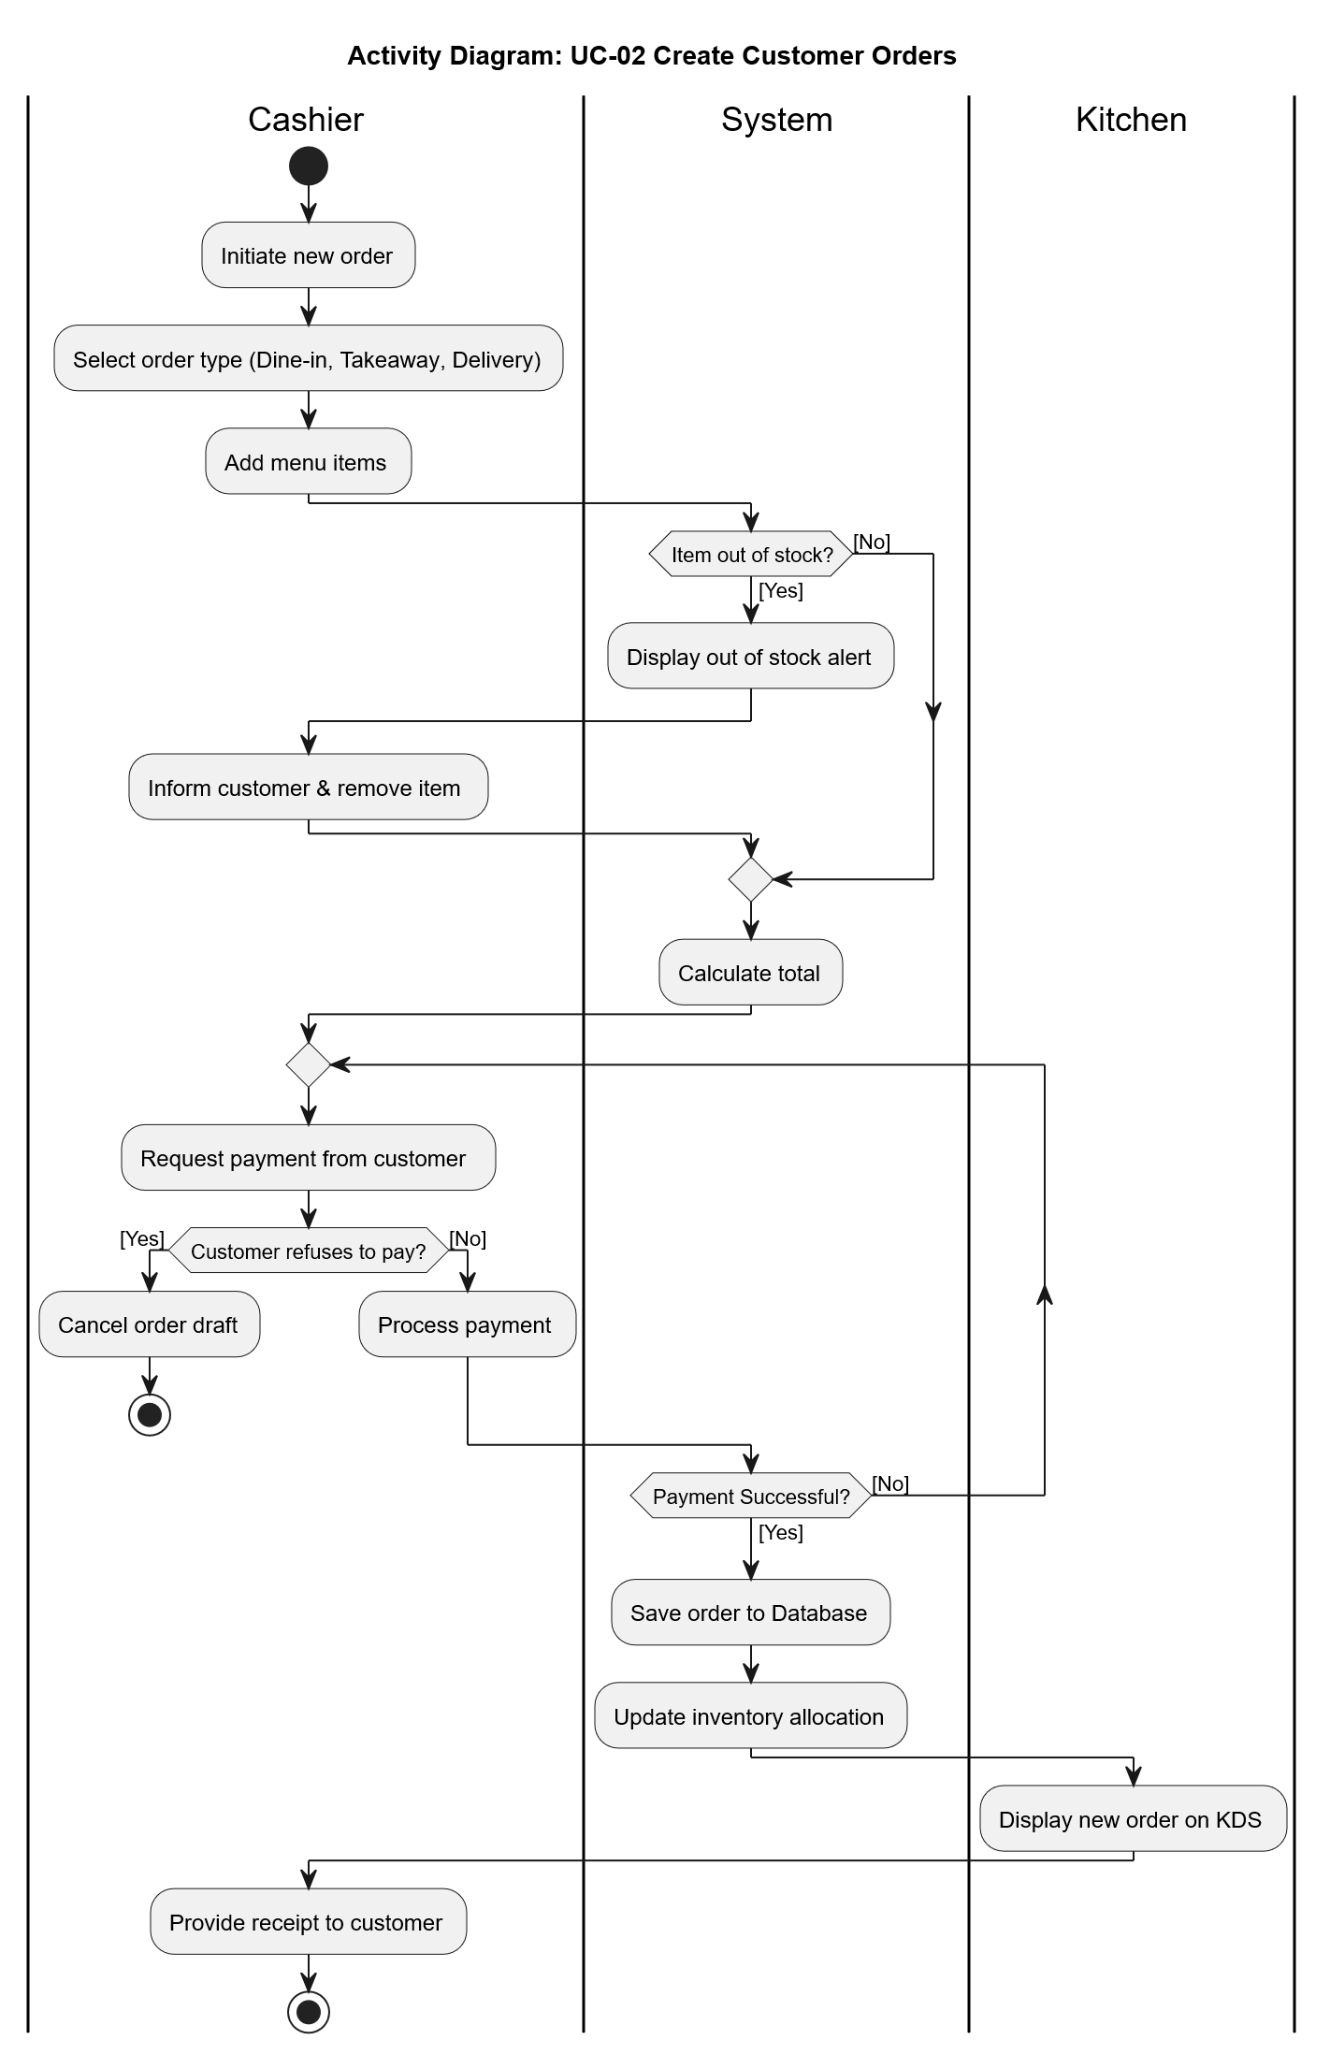

02.

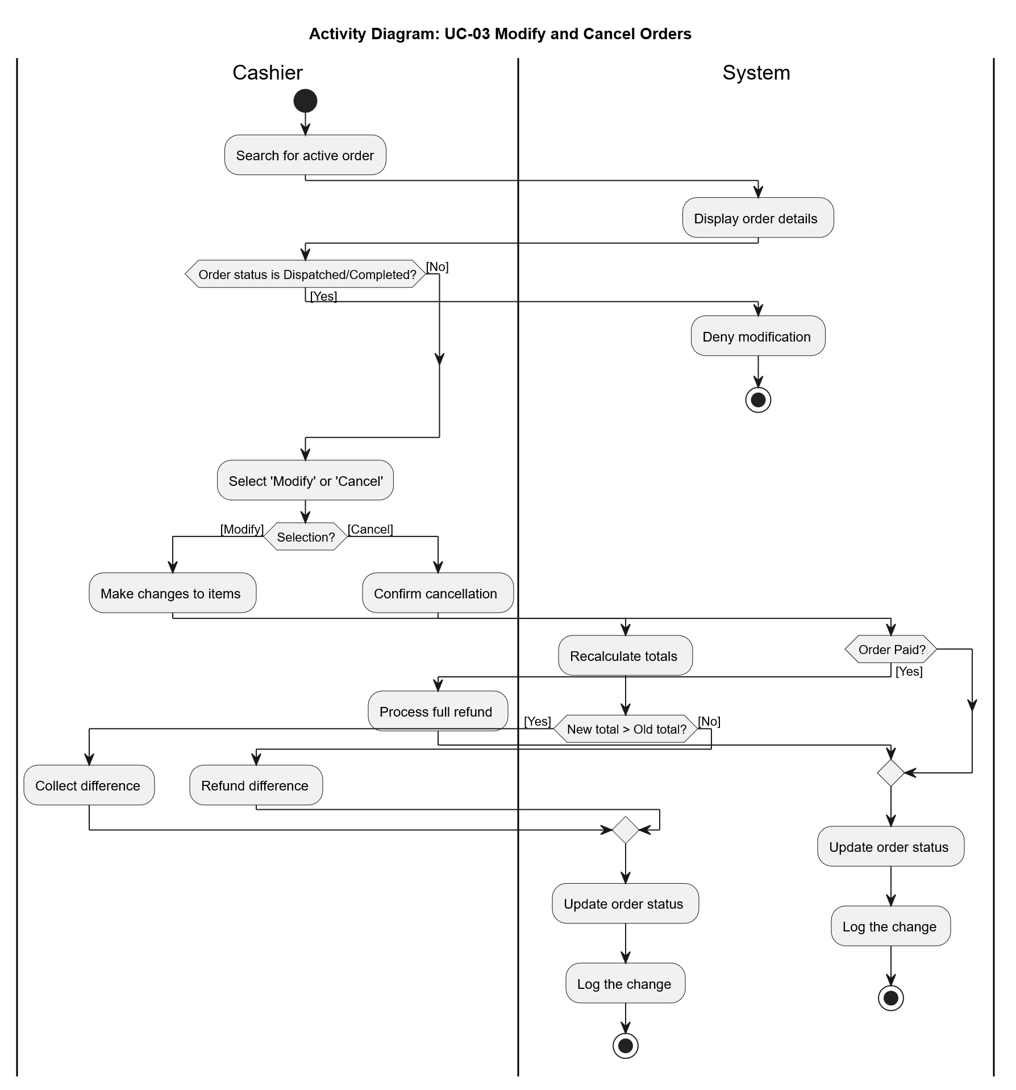

03.
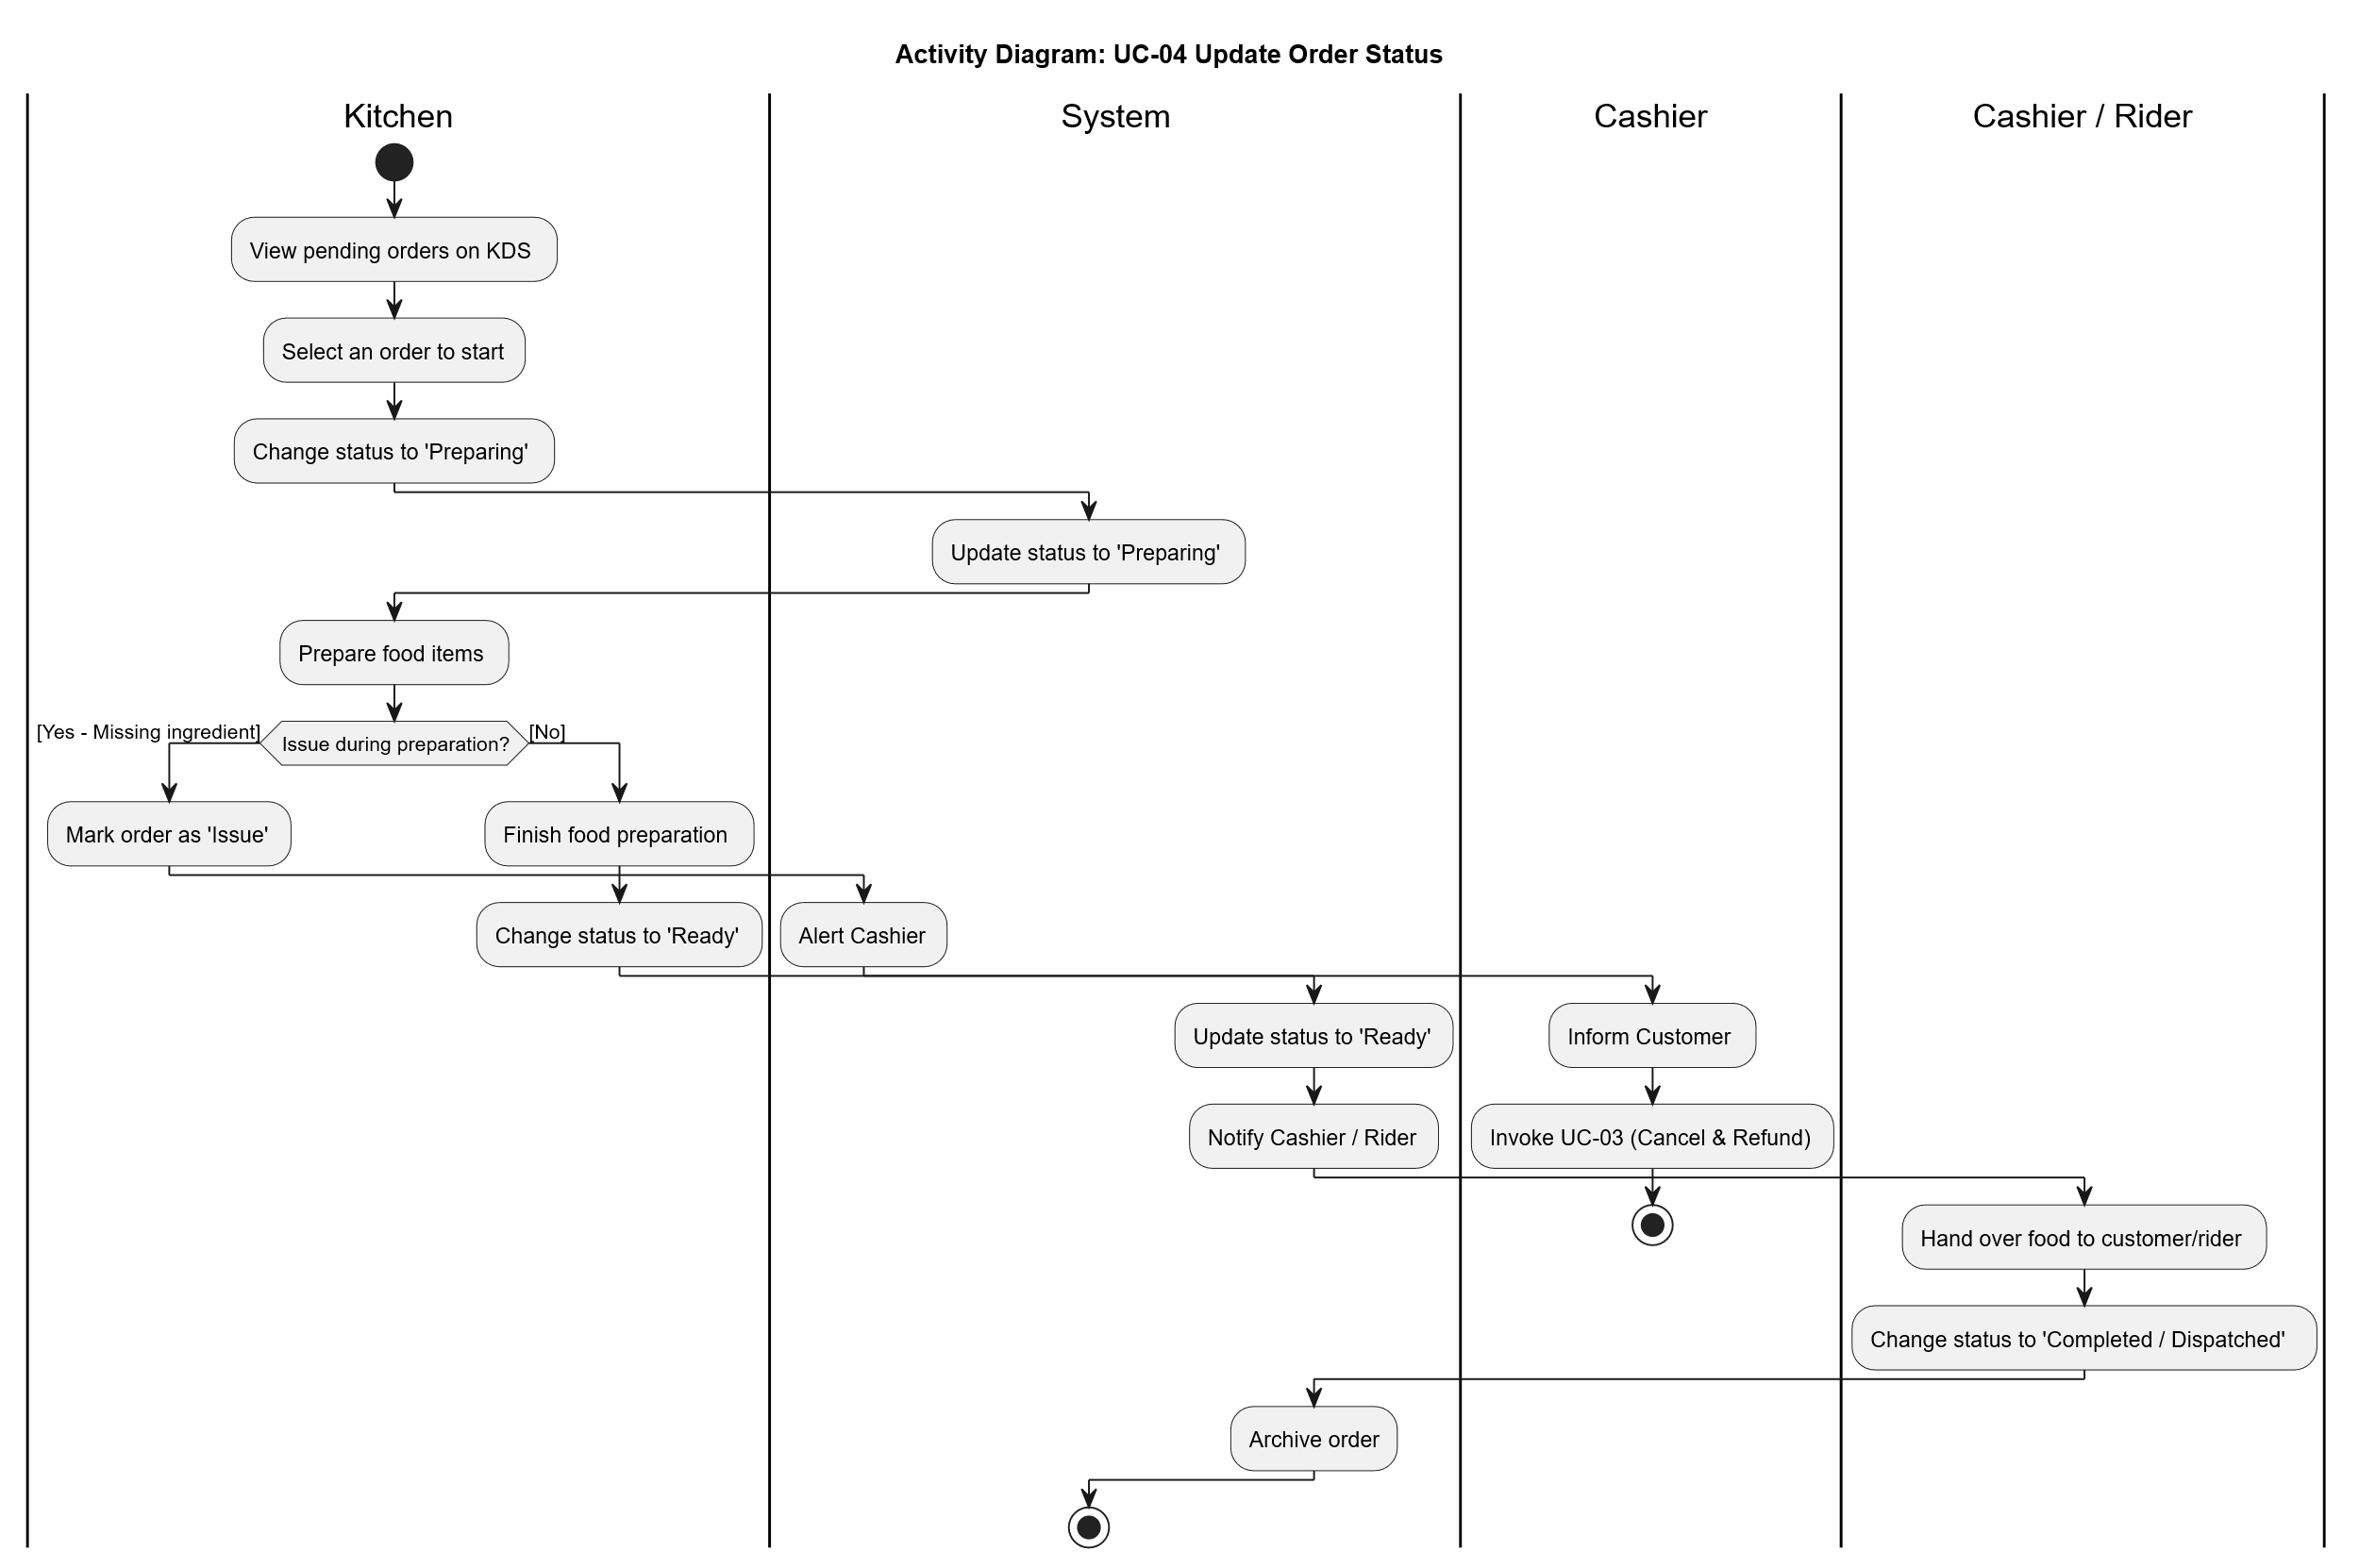

04.

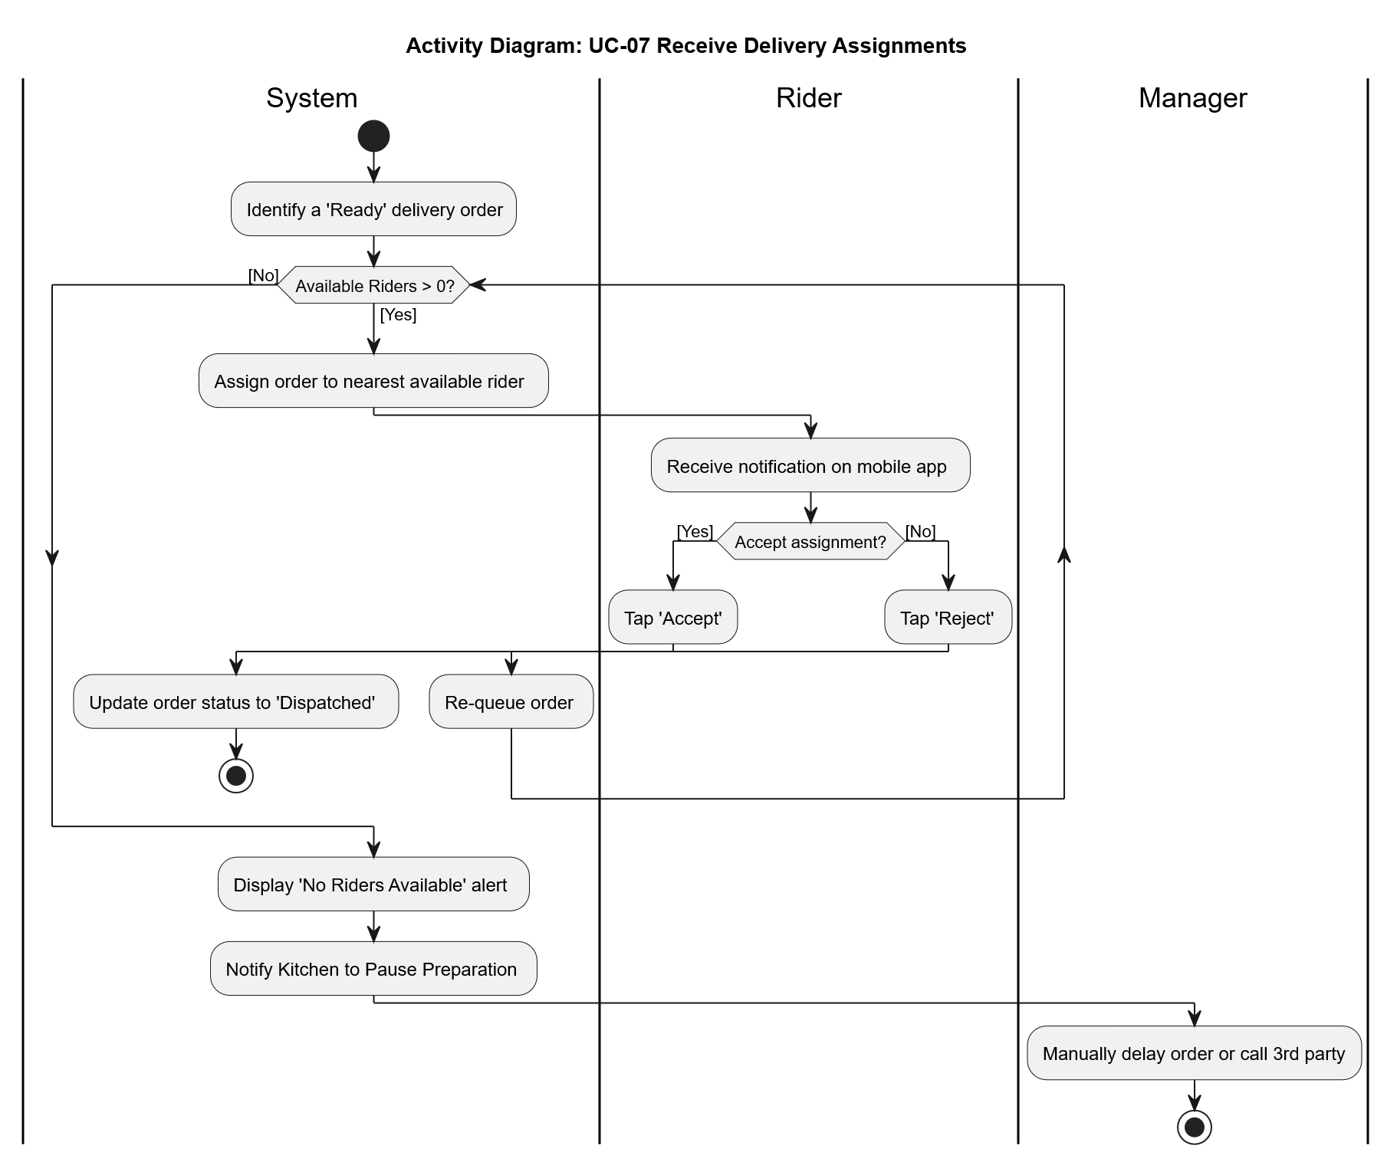

05.

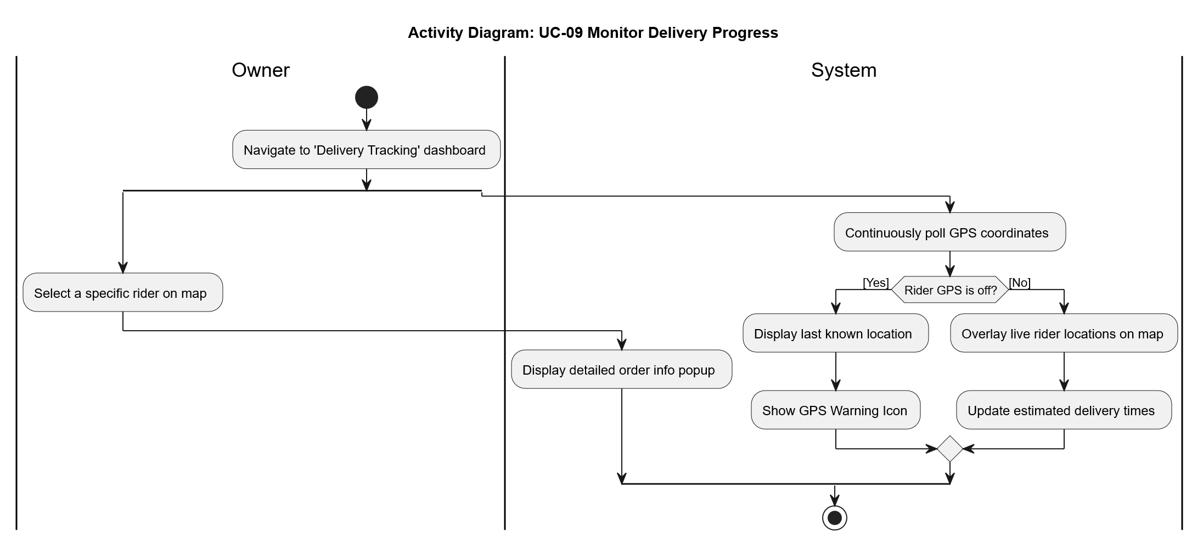

06.

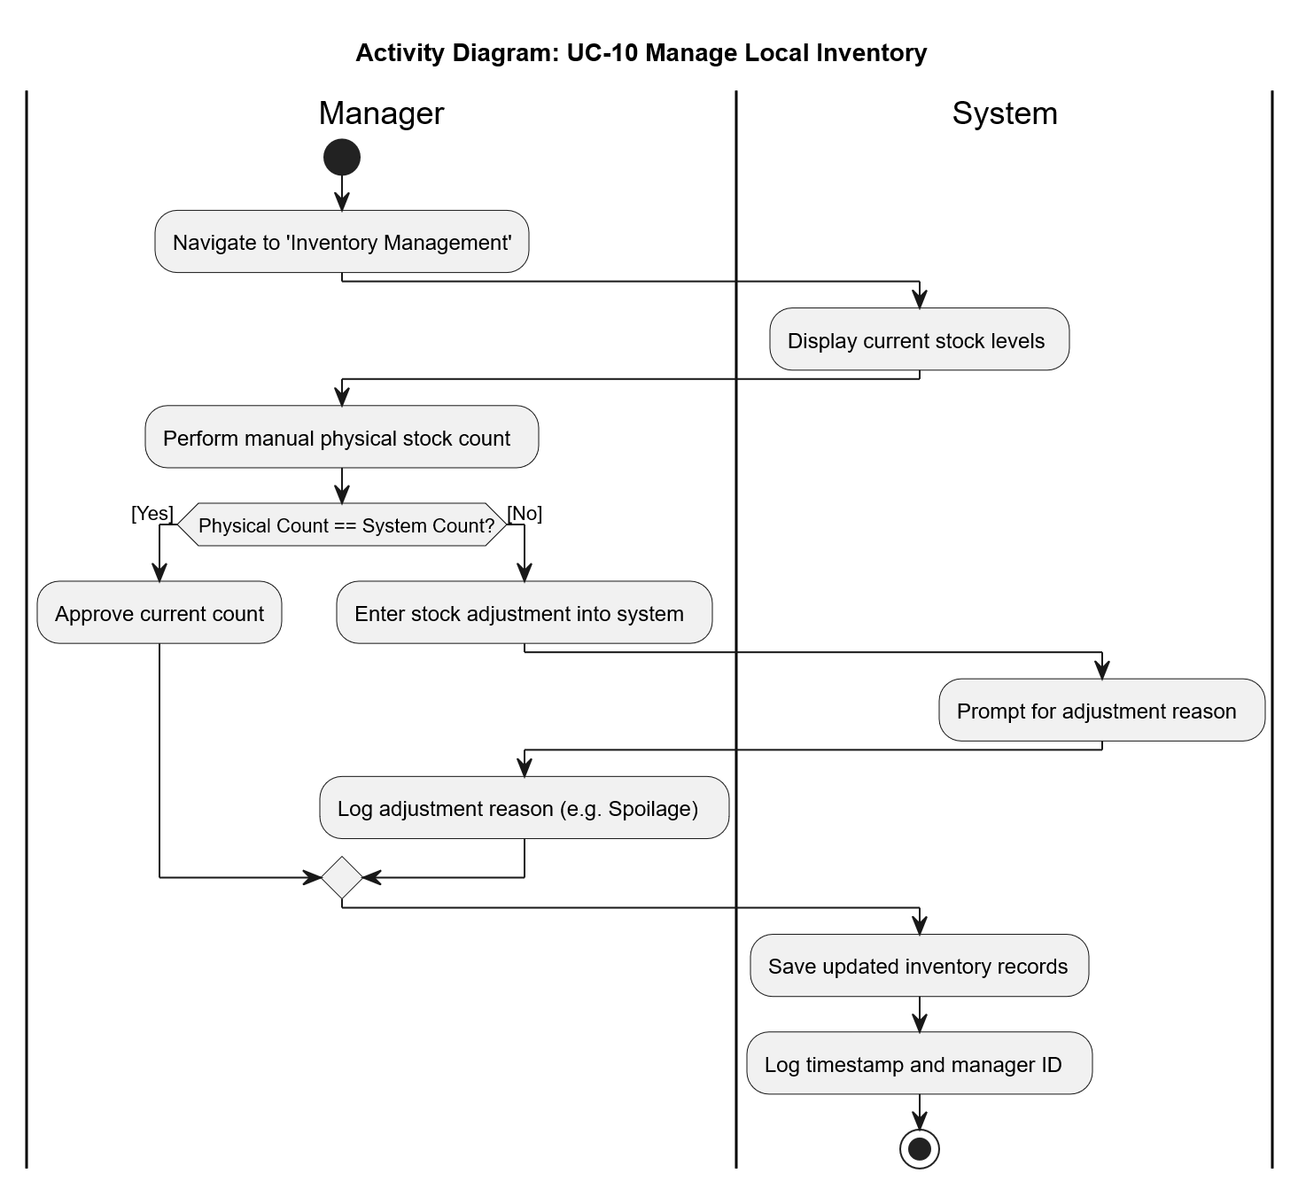

  - System Sequence Diagrams (high-level)

- Functional Requirements

ID | Requirement
FR-01 | System shall capture online/walk-in orders centrally, replacing WhatsApp.
FR-02 | System shall calculate and generate digital bills/invoices at POS.
FR-03 | Rider App shall provide live GPS location of riders to the Owner Dashboard.
FR-04 | Riders shall be able to update delivery status (Dispatched, Delivered).
FR-05 | System shall automatically adjust local branch inventory after a completed sale.
FR-06 | System shall generate automated alerts when stock falls below minimum threshold
FR-07 | Owner dashboard shall aggregate daily/weekly revenue data across all 3 branches
FR-08 | System shall support digital leave application and shift scheduling for employees.
FR-09 | System shall enforce role-based access control (Owner, Rider, Staff).

- Non-Functional Requirements
- Performance: The POS interface must reflect order updates within 2 seconds. The system must efficiently handle concurrent requests from all three branches.
- Security: Secure authentication required. Business data must be protected against unauthorized access. Audit logs must track user actions.
- Usability: The interface must be highly intuitive, catering to kitchen staff and riders who may lack technical expertise.
- Reliability: System must utilize offline-sync to prevent data loss during network outages.
- Scalability: Must seamlessly support the addition of future branches without performance degradation.
- Maintainability: Modular architecture (React, Node.js) to allow easy updates.

- Alternative Solutions & Feasibility Study

